SALESFORCE

GAS FILLING STATION
Project Documentation

Introduction
Salesforce is game-changing technology, with a host of productivity-boosting features, that will help you sell smarter and faster.
About project
A Gas Filling Project in Salesforce typically refers to a custom application or solution built on the Salesforce platform (usually within Sales Cloud, Service Cloud, or a custom Lightning App) to manage operations for companies involved in LPG/CNG/Industrial Gas distribution and refilling.

⚙️ Salesforce Features Used:
- Lightning App Builder for building custom pages and flows
- Process Builder / Flow Builder for automation (e.g., auto-update status after delivery)
- Reports & Dashboards for operational tracking
- Salesforce Mobile App for field agents
- Community/Experience Cloud (optional) for customers to place orders themselves
- Integration APIs (optional) for integrating with IoT sensors or ERP systems

What is Salesforce?
Salesforce is a cloud-based customer relationship management (CRM) platform that helps businesses manage their relationships with customers, streamline operations, and boost productivity across departments like sales, customer service, and more.

Steps to Create a Developer Account and Account Activation in Salesforce

Go to the Salesforce Developer Signup Page
- Visit: https://developer.salesforce.com/signup
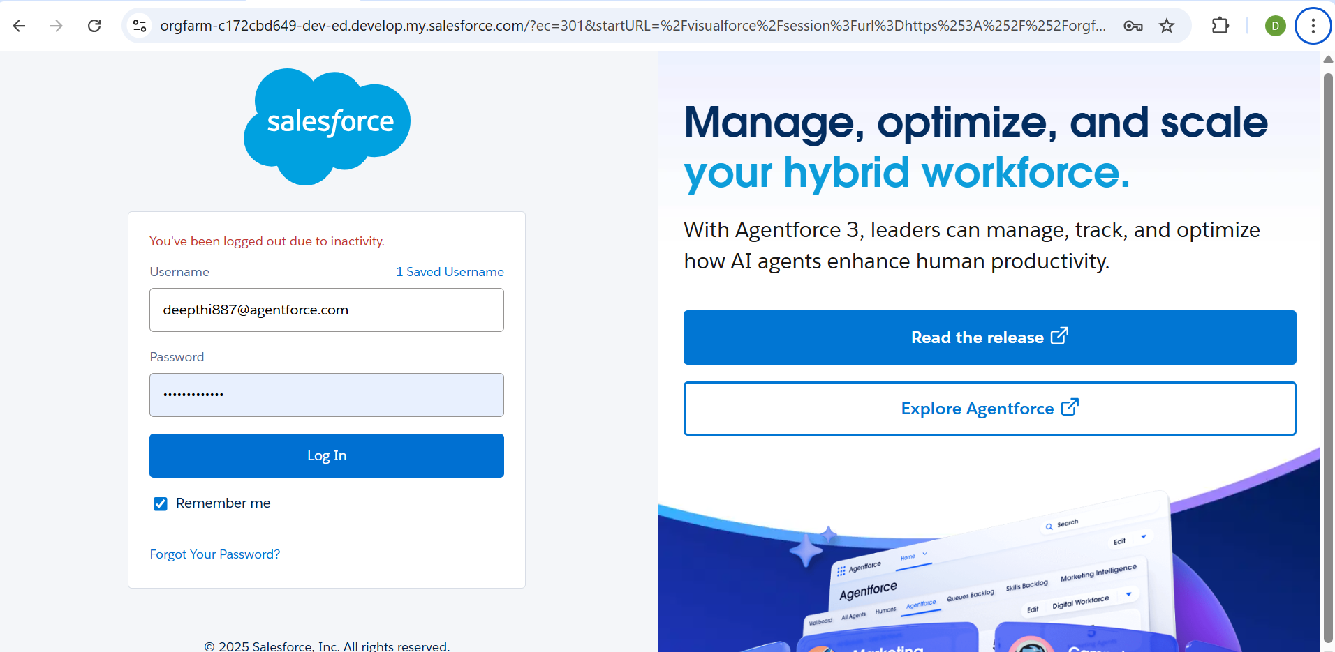
- We are able to see this page.Now we should give information and login into the page
⚠️ Important: Your Username must be unique across all Salesforce accounts.

Confirm Your EmailSalesforce will send you a verification email.
- Click the verification link in the email to activate your account.
- Once you click the link, you'll be prompted to set:
  - A new password
  - A security question
- Use: https://login.salesforce.com
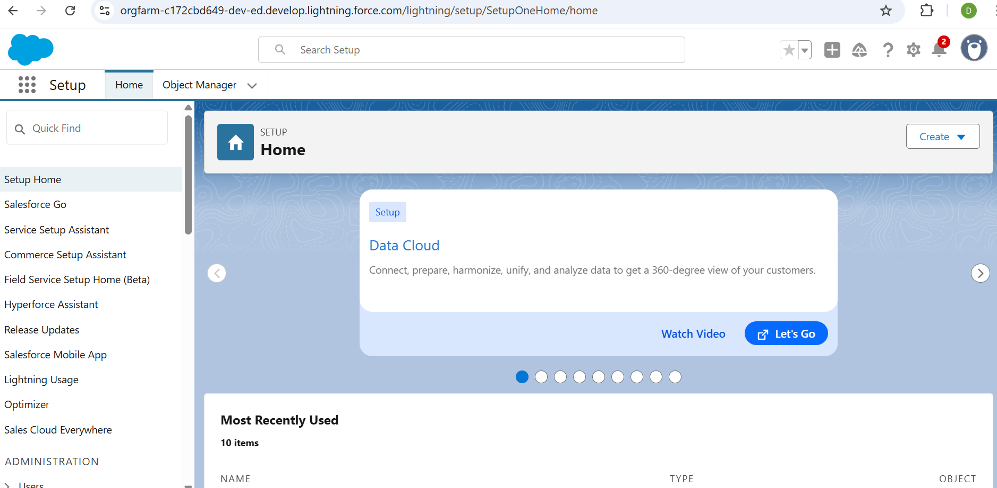

- Now the next step is to create Objects.

What is an object?
In Salesforce, an object is a database table that stores data relevant to a specific entity such as customers, products, or sales transactions.
- Object = A table
- Field = A column
- Record = A row

Custom Objects
These are user-created to store information specific to your organization’s needs.
Example:
- Gas_Cylinder__c – to store details about gas cylinders
- Inspection_Report__c – to log safety inspections
🔸 Custom object names always end in __c.

🔧 Object Components:
Each object (standard or custom) has:
- Fields – Like Name, Date, Status, etc.
- Records – Individual entries in that object
- Page Layouts – How data is displayed on a page
- Relationships – Links to other objects (like foreign keys)
- Validation Rules – To enforce data quality
- Automation – Flows, triggers, or process builders tied to the object
Creation of objects:
- Log in to Salesforce.
- Go to https://login.salesforce.com
- Use your developer account credential
ii. Navigate to Setup
- Click the gear icon (⚙️) in the top-right corner
- Select "Setup"
iii. Go to Object Manager
- In the top menu bar, click “Object Manager”
iv. Create a New Custom Object
- Click the "Create" dropdown (or the “Create Custom Object” button if available)
- Click “Custom Object”
v. Define the Object Properties
- Fill in the following fields:
  - Label (e.g., Invoice)
  - Plural Label (e.g., Invoices)
  - Object Name (auto-filled based on Label, but can be edited)
  - Optionally set:
    - Record Name field (defaults to text but can be auto-numbered)
    - Enable options like:
      - Allow Reports
      - Allow Activities
      - Track Field History
      - Allow in Chatter
      - Launch New Custom Tab Wizard (recommended if you want a UI tab for it)
vi. Save the Object
  - Click SAVE. 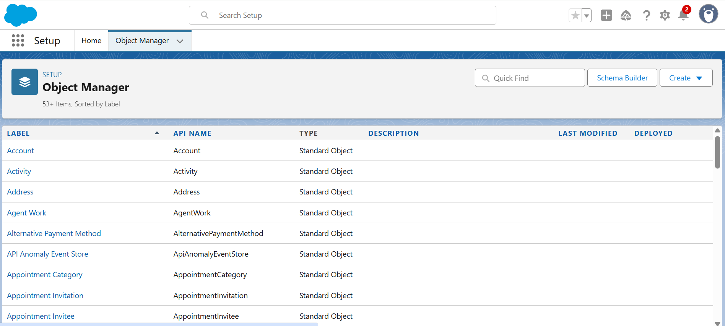
- If you selected to launch the tab wizard, continue to create a tab.

Creation of Tabs

1. Go to Setup
- Click the ⚙️ Gear icon in the upper-right corner.
- Select Setup.

2. Find the Tabs Setup Page
- In the Quick Find box on the left sidebar, type “Tabs”.
- Click on “Tabs” under User Interface.

3. Create a New Custom Object Tab
- Scroll to the section Custom Object Tabs.
- Click the “New” button.

4. Configure the Tab Settings
- Object: Choose your custom object (e.g., Invoice__c).
- Tab Style: Choose an icon and color for the tab.
- Optionally, click “Create a new style” if you want a custom icon.
- Description (optional): Add a brief description of the tab.
Note: You cannot create tabs for standard objects (like Account or Contact), only for custom objects, Visualforce pages, Lightning components, or web tabs.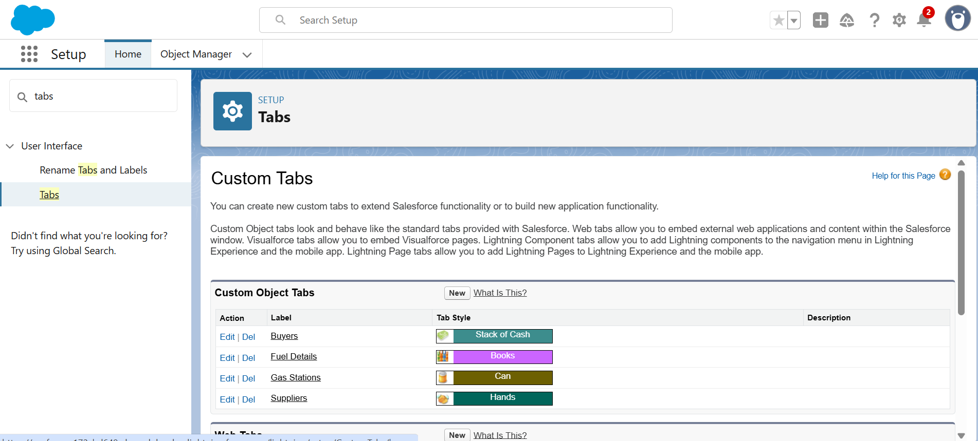

5. Assign Tab Visibility to Profiles
- Choose the default tab visibility for each user profile:
  - Default On: Tab is visible by default.
  - Default Off: Tab is hidden but available.
  - Tab Hidden: Tab is not visible or accessible.
You can later modify tab visibility via Permission Sets or Profile settings.

6. Add Tab to App Navigation (Optional but Recommended)To make the tab appear in an app:
- In Setup, go to App Manager.
- Find your app (e.g., “Sales” or a custom app).
- Click the dropdown (▼) and select Edit.
- Under Navigation Items, click Add and select your new tab.
- Save and Finish.

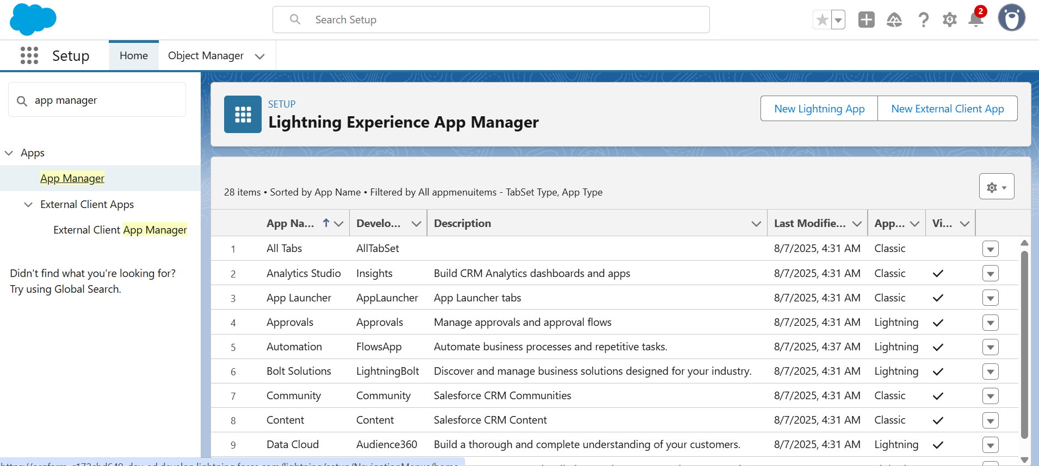
- Lightning App:
A Lightning App in Salesforce is a custom collection of items (like objects, tabs, pages, and utilities) designed to provide users with a streamlined experience tailored to specific business functions—such as Sales, Service, or a custom department workflow.

Steps to create a Lightning App:

🔍 Open App Manager
- In the Quick Find box on the left, type “App Manager”.
- Click “App Manager” under the Apps section.

➕ Create a New Lightning App
- In the top-right of the App Manager, click “New Lightning App.”
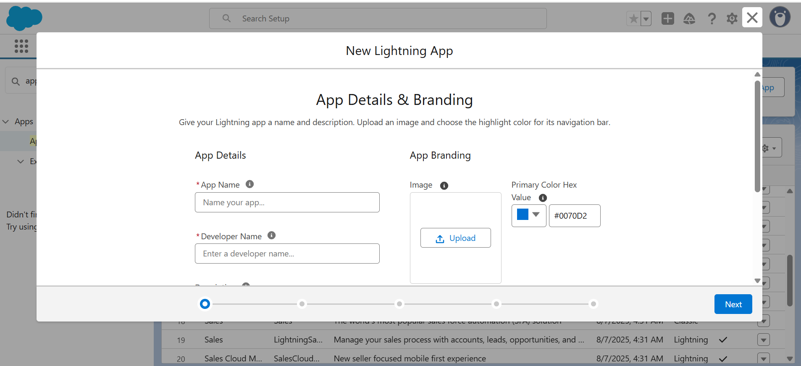

📋 Fill App Details & Branding
- App Name: (e.g., HR Management)
- Developer Name: Auto-filled.
- Description: (Optional)
- App Branding Options:
  - Upload a logo.
  - Choose a primary color.
Click Next.

🔧 Choose App Options
- App Settings:
  - Enable features like:
    - Setup and App Pages
    - Personalization
    - Lightning Pages
    - Record Pages
- Navigation Style:
  - Standard Navigation: Tabs across the top (best for Sales, HR, etc.)
  - Console Navigation: Split-view interface (best for Service reps)
Click Next.

👥 Assign User Profiles
- Choose which user profiles should have access to this app.
- (You can adjust this later via Profiles or Permission Sets.)
Click Next.
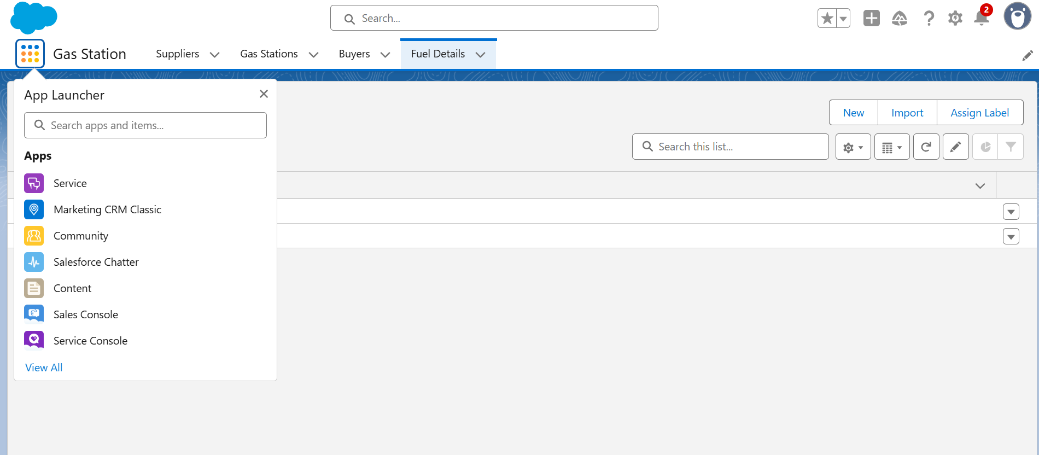
- Fields:
fields are data containers on objects (like Account, Contact, or a custom object like Invoice__c). Each record of an object holds values in its fields — similar to how each row in a spreadsheet contains values in columns.
Creation of Fields

🔹 2. Open Object Manager
- In the top navigation bar, click “Object Manager”.
- Search for and select the object where you want to add the field (e.g., Invoice__c, Account, Opportunity, etc.).

🔹 3. Go to Fields & Relationships
- In the left-hand menu for the selected object, click “Fields & Relationships”.
- Click the “New” button.

🔹 4. Choose the Field Type
- Select the type of field you want to create.
  - Examples: Text, Picklist, Number, Date, Checkbox, Formula, Lookup, etc.
- Click Next.
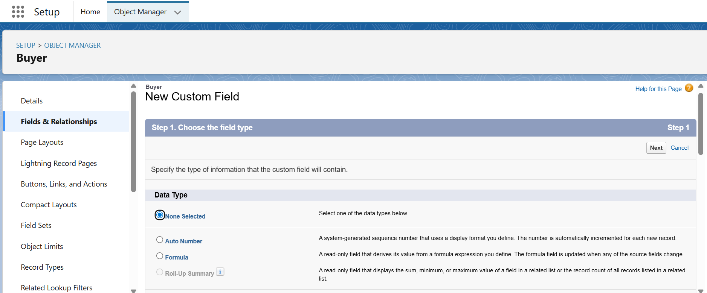

🔹 5. Enter Field Details
- Field Label: The name users will see (e.g., Invoice Status).
- Field Name: Auto-filled (API name, ends with __c for custom fields).
- Depending on field type, you may configure:
  - Length (for Text)
  - Decimal Places (for Number)
  - Picklist Values
  - Default Value
  - Required or not
Click Next when done.

🔹 6. Set Field-Level Security
- Choose which profiles can see or edit this field.
- You can check:
  - Visible (field is visible to profile)
  - Read-Only (field is view-only)
  - Click Next.
👥 7. Assign User Profiles
- Choose which user profiles should have access to this app.
- (You can adjust this later via Profiles or Permission Sets.)
Click Next.

🧭 8. Add Navigation Items
- Choose which tabs should appear in the app’s nav bar.
- These can include:
  - Custom objects (e.g., Invoices__c)
  - Standard objects (e.g., Accounts, Contacts)
  - Reports, Dashboards, Visualforce pages, Lightning Pages, etc.
- Use arrows to move selected items to the right-hand side.
Click Next.
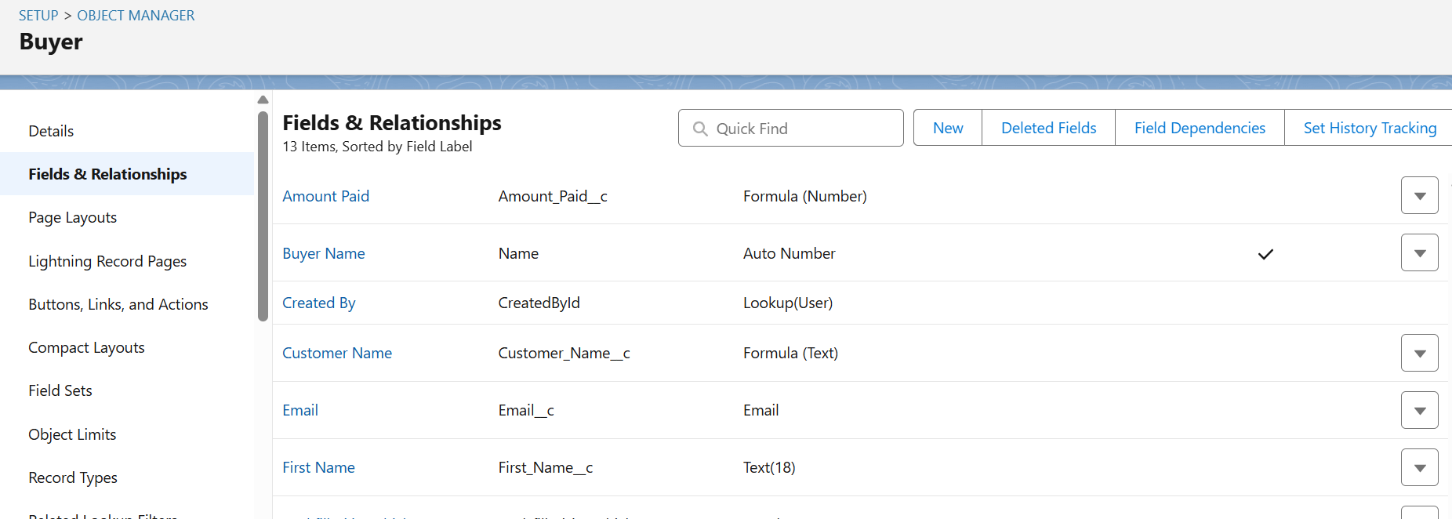

✅ 10. Review and Finish
- Review all the settings.
- Click Finish.

- Page Layouts
Page Layout controls the layout and organization of fields, buttons, related lists, and other elements on a record detail page for a specific object.
Creating Page Layout:

🔍 1. Open Object Manager
- In Setup, go to Object Manager (top of page).
- Search for and select the object (e.g., Account, Opportunity, Invoice__c).

🧱 2. Go to Page Layouts
- In the left-hand panel, click “Page Layouts”.

✏️ 3. Edit or Create a Layout
- To edit: Click the layout name (e.g., Account Layout).
- To create: Click “New”, choose a layout to clone, give it a name, then click Save.

🎨 4. Customize the Layout
You can now drag and drop components into the layout:

🔸 Fields
- Drag fields from the top section into the layout.
- Remove unwanted fields by clicking the wrench icon > Remove.

🔸 Sections
- Add sections (e.g., Personal Info, Status, Internal Notes).
- Choose 1-column or 2-column layout for each section.

🔸 Buttons
- Add/remove standard/custom buttons.

🔸 Related Lists
- Add related objects (like Cases, Activities).
- Customize columns shown in each list.

🔸 Custom Links & Visualforce Pages
- Insert these into custom sections if needed.

🔐 5. Set Field Properties
- Click a field → Set as Required or Read-Only (field-level, not global).

💾 6. Save the Layout
- Click Save to apply your changes.

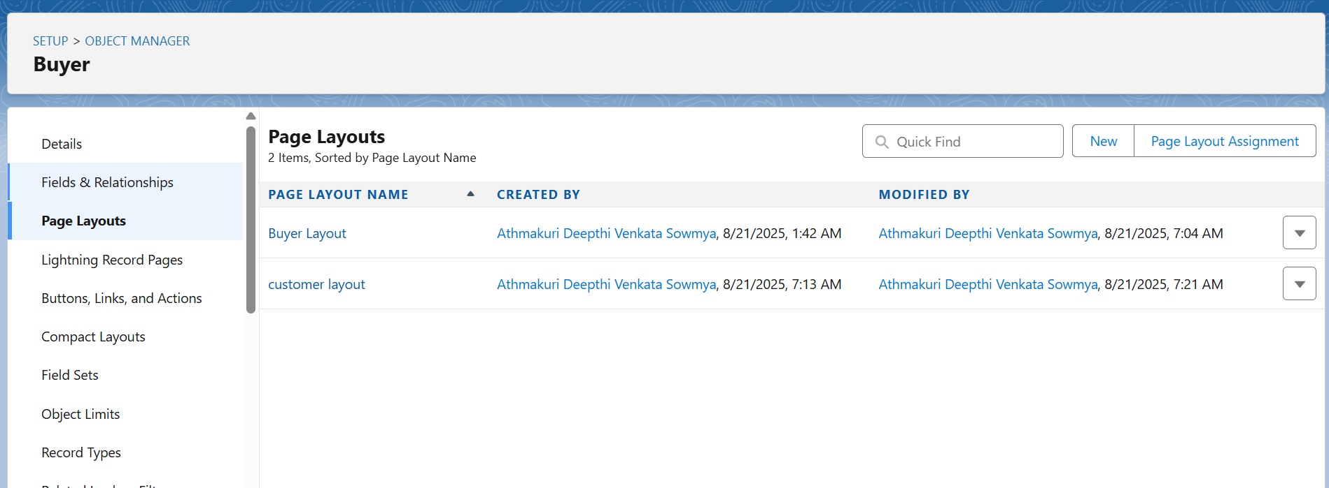

- Profiles
Profile is a collection of settings and permissions that define what users can see and do within the system.
Types of Profiles:
Profile Type | Description
Standard Profiles | Default profiles provided by Salesforce (e.g., System Administrator, Standard User, Read Only). Cannot be deleted.
Custom Profiles | Created by admins to suit specific roles. You can fully customize these.

🔧 Steps to View or Edit Profiles

1. Go to Setup
- Click the ⚙️ Gear icon → Select Setup.

2. Find Profiles
- In the Quick Find box, type “Profiles”.
- Click Profiles under Users.

3. Select a Profile
- Choose a standard profile to view, or clone it to create a custom one.
- For full control, create or edit a custom profile.

4. Configure Profile Settings

✳️ Key Sections:
- Object Settings: Set CRED access for each object.
- Field-Level Security: Decide which fields are visible/editable.
- App Settings: Choose visible apps and default app.
- Tab Settings: Show, hide, or default tabs.
- Record Type Settings: Choose available record types.
- Administrative Permissions: E.g., Modify All Data, View Setup.
- Login Hours/IP Ranges: Control login access.

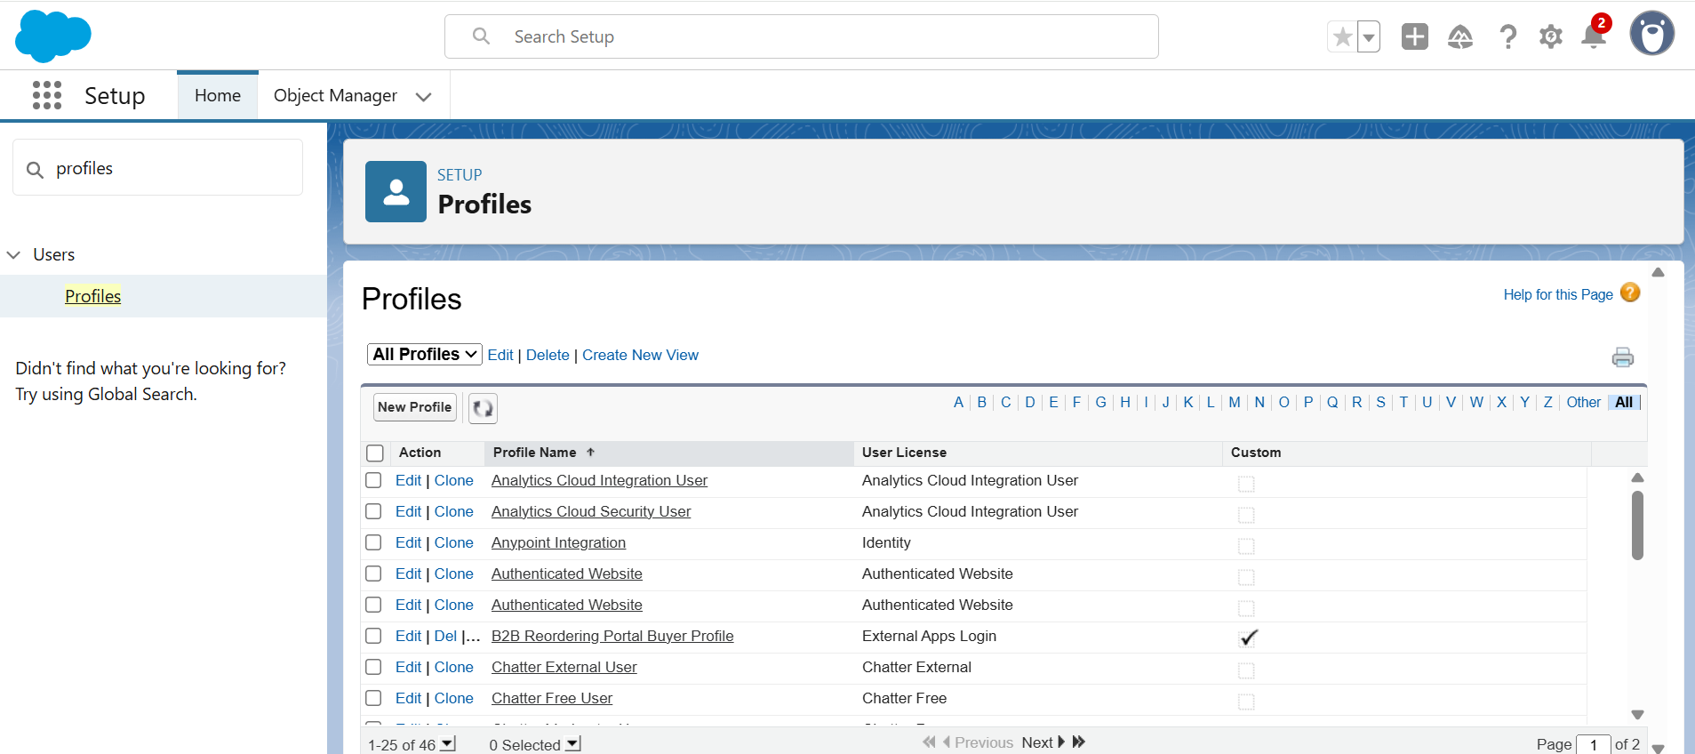
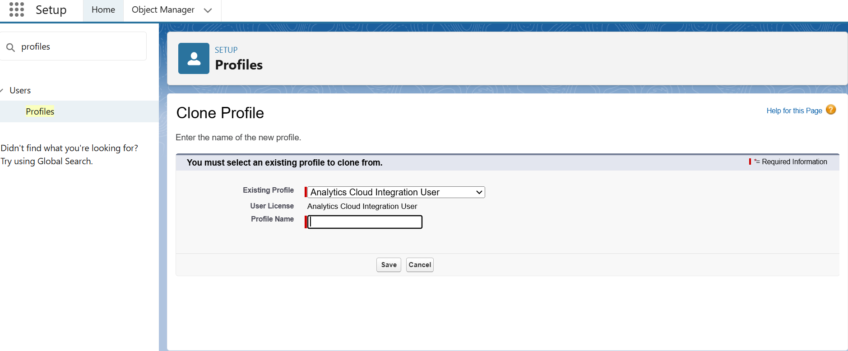
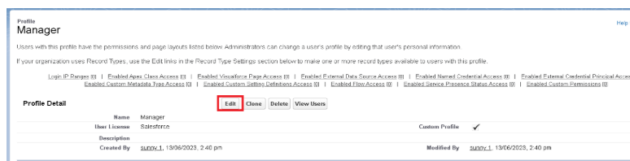
- Roles
A Role in Salesforce defines what records a user can see, based on their place in the organization’s hierarchy — it controls record-level sharing, not field or object-level permissions.

🔧 How to Set Up Roles in Salesforce

Step-by-Step:

✅ 1. Go to Setup
- Click the Gear icon (⚙️) → Setup

✅ 2. Search for "Roles"
- In the Quick Find, type “Roles”
- Click Roles under Users

✅ 3. View the Role Hierarchy
- You'll see a tree view of your current role structure.
- Salesforce provides a default hierarchy, but you can customize it.
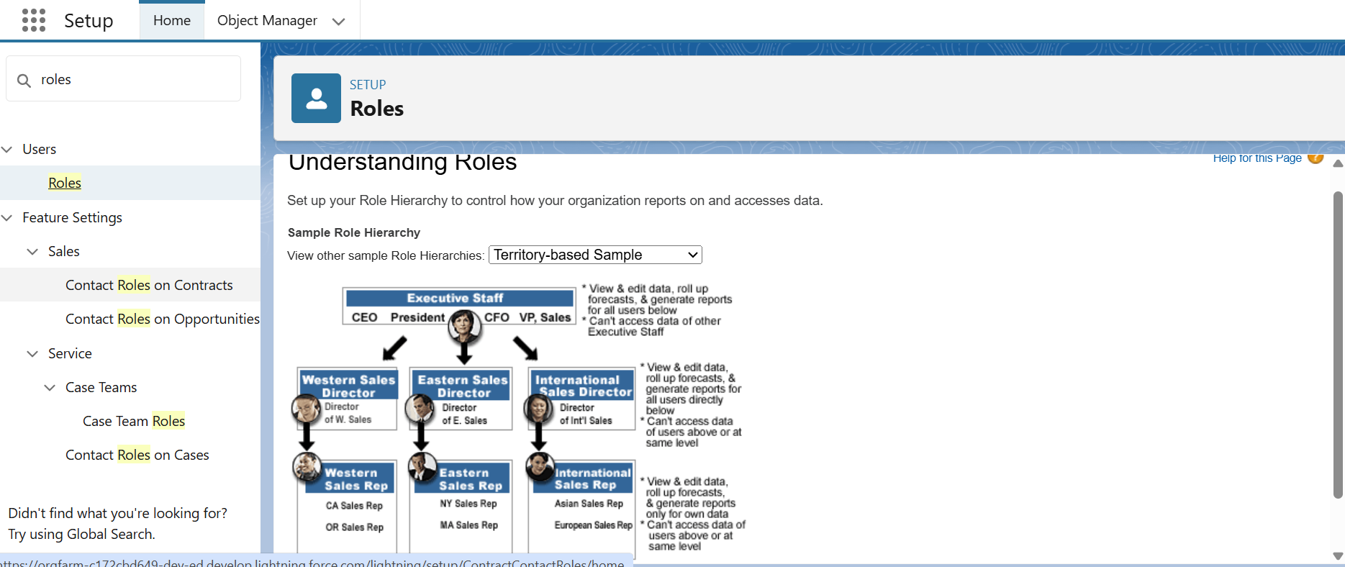

✅ 4. Add or Edit a Role
- Click “Add Role” or select an existing role to edit.
- Fill in:
  - Label (e.g., Sales Manager)
  - Role Name (used internally)
  - Parent Role (who this role reports to in the hierarchy)
  - Opportunity Access settings (for role-based access)
Click Save.

✅ 5. Assign Roles to Users
- Go to Setup → Users → Users
- Edit the user you want.
- Select a Role from the dropdown.
- Save.
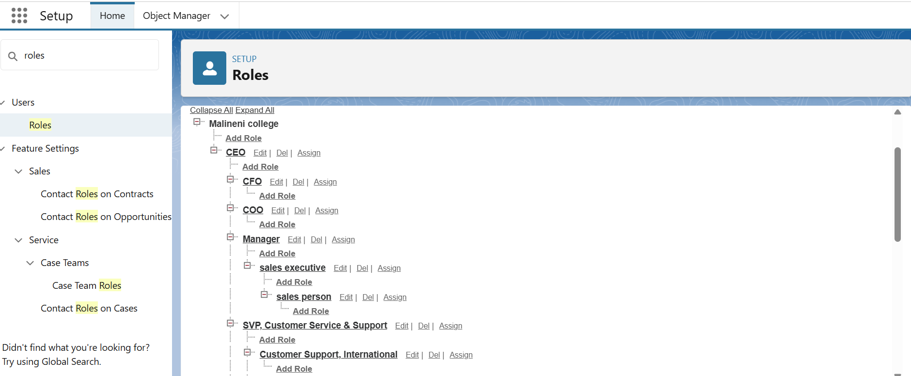
- Users
User is anyone who can log in to the Salesforce org. Each user has a user record that defines their login credentials, access, and settings.

✅ Steps to Create a User in Salesforce

1. Go to Setup
- Click the ⚙️ Gear icon → Select Setup

2. Find Users
- In the Quick Find box, type “Users”
- Click Users under Users section

3. Click “New User”
- You'll be taken to the user creation form.

4. Fill in the User Details

Field | Description
First Name / Last Name | User’s name
Alias | Short name (auto-filled)
Email | User’s email address
Username | Must be unique; often same as email (format: email@example.com)
Nickname | Auto-generated
License | Choose the appropriate user license (e.g., Salesforce, Platform, Service Cloud)
Profile | Choose a profile (e.g., Standard User, System Admin)
Role | Assign a role from your role hierarchy
Time Zone | Set user’s local time zone
Locale / Language | Choose appropriate settings
Active | Checkbox must be selected for the user to log in

5. Click Save
🎉 The user will receive an email to set their password and log in.
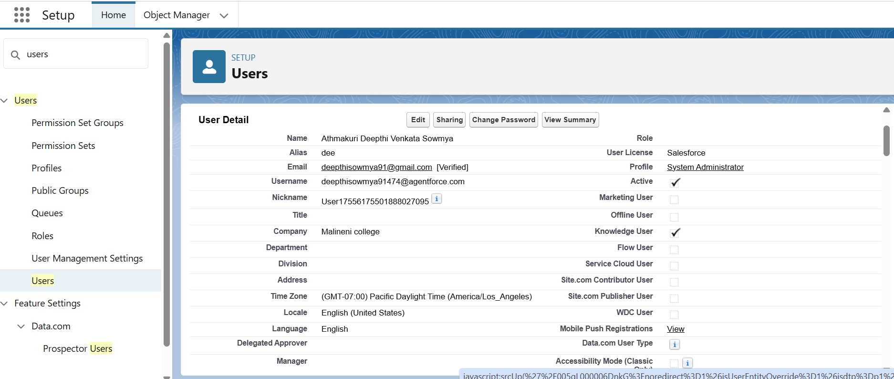
- Permissio Sets
Permission Set is a way to grant additional access to users without changing their profile. This allows for more flexible and scalable user management.

🛠️ How to Create a Permission Set in Salesforce

🔹 Step 1: Go to Setup
- Click the ⚙️ Gear icon → Setup

🔹 Step 2: Search and Click "Permission Sets"
- In the Quick Find box, type "Permission Sets"
- Click Permission Sets under Users

🔹 Step 3: Click “New”
- Fill in the details:
  - Label: (e.g., Can Export Reports)
  - API Name: Auto-filled
  - User License: Choose:
    - “--None--” to make it available for any user license
    - Or choose a specific license (e.g., Salesforce Platform)
  - Click Save

🔹 Step 4: Add Permissions
Once your permission set is created, open it and configure:
Section | What You Can Add
Object Settings | CRED access for specific objects
Field Permissions | Visibility or Read-Only per field
Apex Class Access | Grant access to Apex code
Visualforce Page Access | Allow use of Visualforce pages
System Permissions | Enable abilities like “Export Reports”, “Use REST API”
App Permissions | Access to apps or features like Knowledge, Einstein
Use the "Edit" button in each section to add specific permissions.

🔹 Step 5: Assign the Permission Set to Users
- Go to the Permission Set
- Click "Manage Assignments"
- Click "Add Assignments"
- Select users → Click Assign

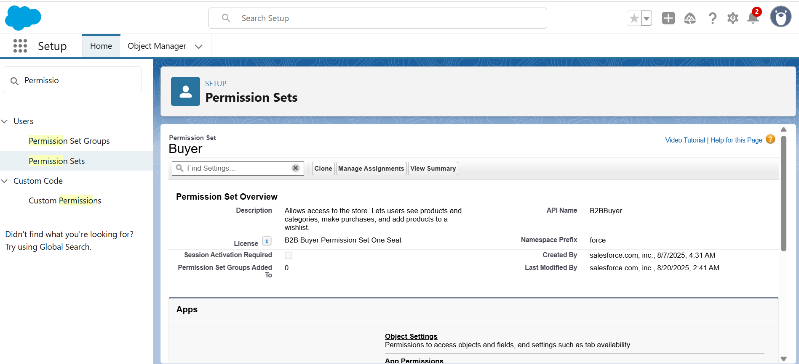
- Setup for OWD
Setting up OWD (Organization-Wide Defaults) in Salesforce is a critical part of record-level security. OWD determines the baseline level of access to records for all users in your org. You can then open up access using roles, sharing rules, teams, or manual sharing.

⚙️ How to Set Up OWD in Salesforce

✅ Step-by-Step Guide:

🔹 1. Go to Setup
- Click the ⚙️ Gear icon → Select Setup

🔹 2. Search for “Sharing Settings”
- In the Quick Find box, type “Sharing Settings”
- Click “Sharing Settings” under Security

🔹 3. Find the Organization-Wide Defaults Section
- On the Sharing Settings page, scroll down to the "Organization-Wide Defaults" section.

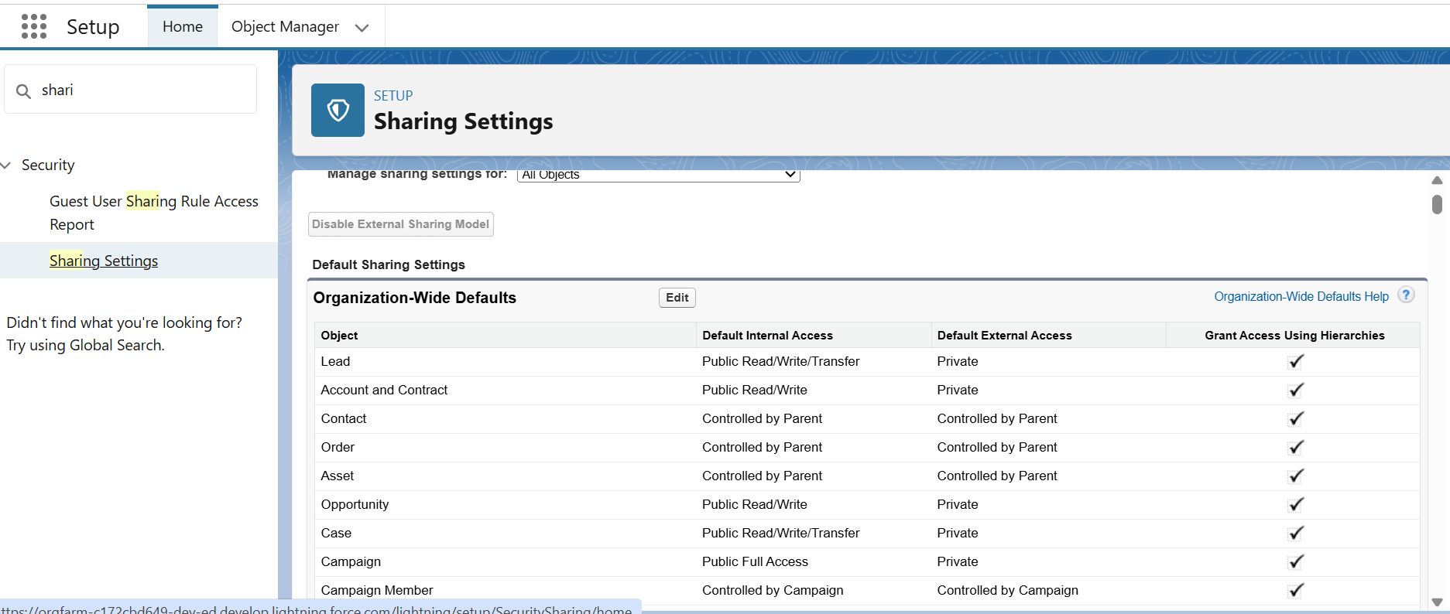

🔹 4. Click “Edit”
- Click the Edit button at the top of the OWD table.

🔹 5. Set Default Access Levels for Each Object
For each object (standard or custom), set the default access level:
Object | Recommended OWD
Accounts | Private or Public Read Only
Contacts | Controlled by Parent (if linked to Accounts)
Opportunities | Private (especially for Sales teams)
Cases | Public Read/Write or Private
Custom Objects | Depends on your use case
⚠️ Be cautious with Public Read/Write — it's rarely appropriate for sensitive data.

🔹 6. Save Changes
- Click Save at the top or bottom of the page.
- User Adoption
User Adoption in Salesforce refers to how effectively users engage with, use, and benefit from the Salesforce platform in their daily work. It's not just about logging in — it's about using Salesforce the right way, consistently, and as intended by the business.

✅ 1. Create a Record

📍 Steps:
- Log in to Salesforce.
- Open the App Launcher (9-dot icon, top-left corner).
- Search for and select the object (e.g., Accounts, Leads, Custom Object like Invoice__c).
- Click the “New” button.
- Fill in the required fields.
- Click “Save”.
🔒 You must have Create permission for the object via your Profile or Permission Set.
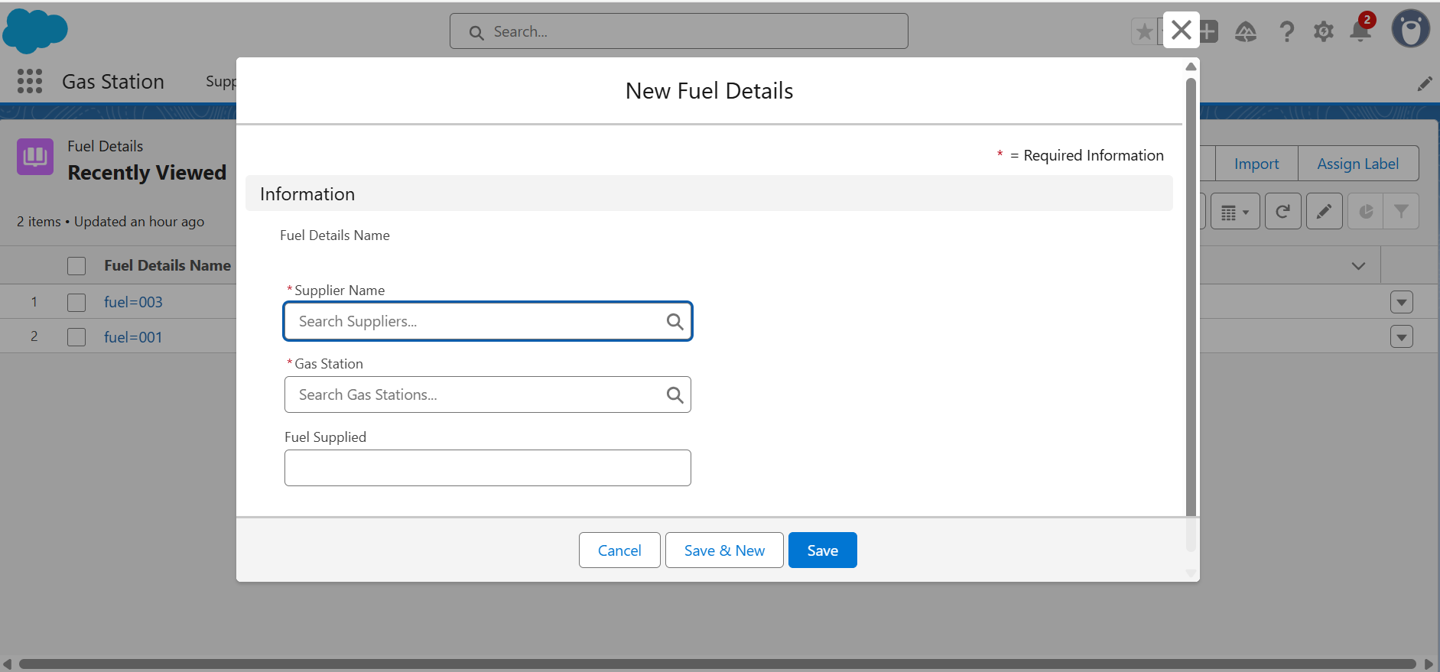

👁️ 2. View a Record

📍 Steps:
- Navigate to the object’s tab (e.g., Accounts).
- Use the List View or Search Bar to find the record.
- Click the record name (e.g., “Acme Corp”) to open its detail page.
- View all fields, related lists (e.g., Contacts, Opportunities), and activities.
🔒 You need Read access on the object and record to view it.

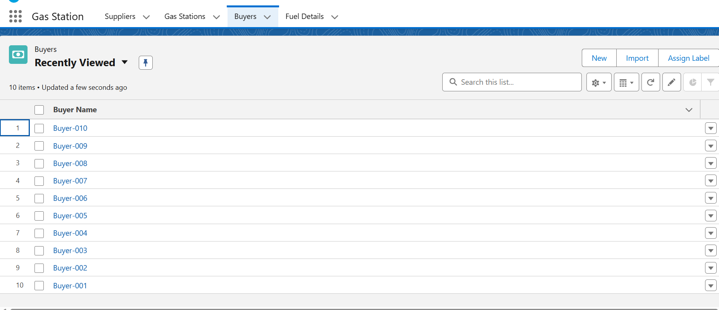

🗑️ 3. Delete a Record

📍 Steps:
- Open the record you want to delete.
- Click the Dropdown (▾) next to the “Edit” button.
- Select “Delete”.
- Confirm the deletion when prompted.
🔒 You need Delete permission on the object and ownership or higher role access to delete a record.
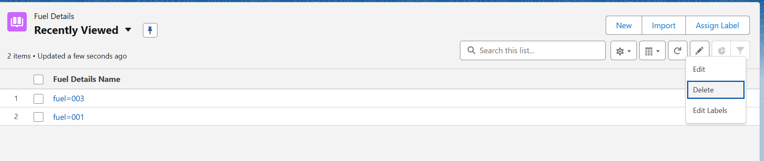
- Reports
A Report is a list of records that meet specific criteria, grouped and displayed in rows and columns, often with charts, summaries, and filters.
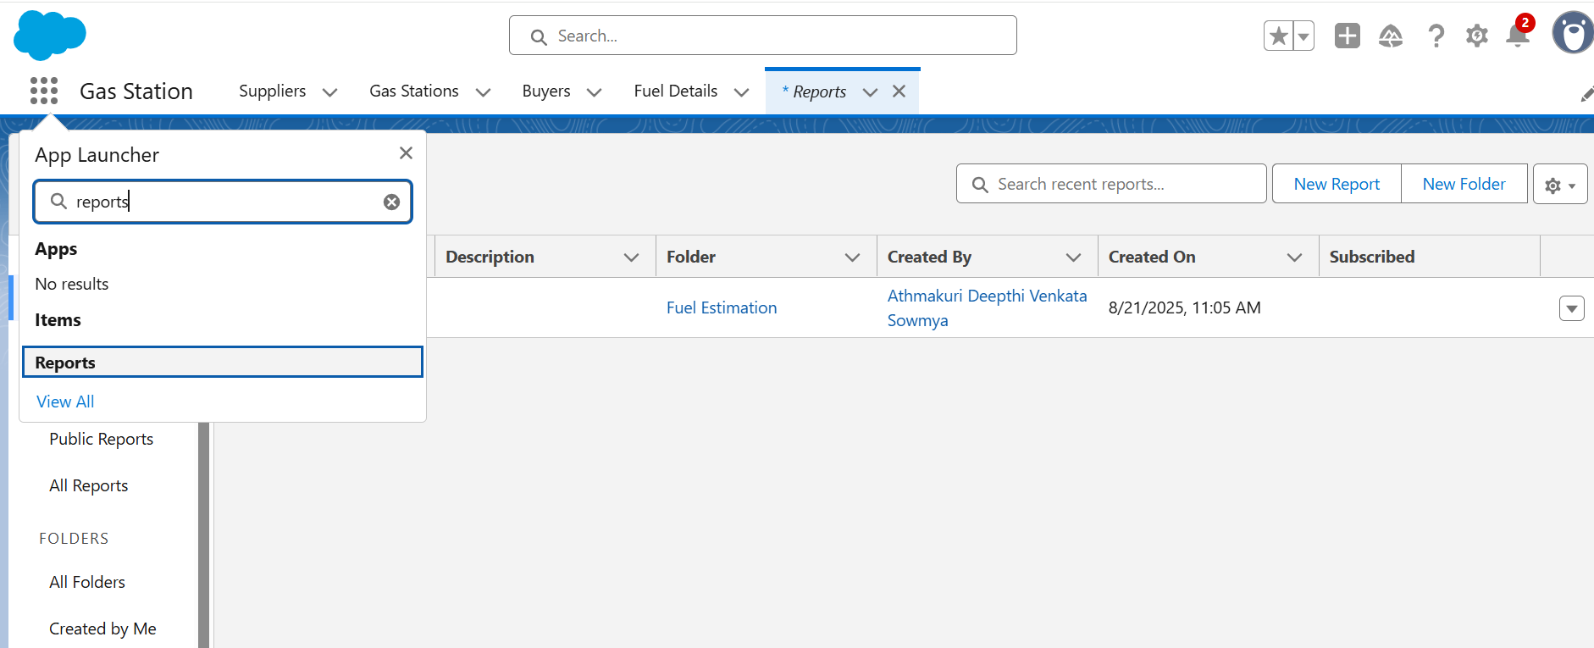

✅ 1. Create a Report Folder

📍 Steps:
- Go to the Reports tab in the App Launcher.
- Click on the “All Folders” on the left sidebar.
- Click “New Folder” (top right).
- Enter:
  - Folder Name (e.g., Sales Reports Q3)
  - Folder Label (auto-filled)
- Click Save.
📁 Your new folder is now available to store reports and dashboards.
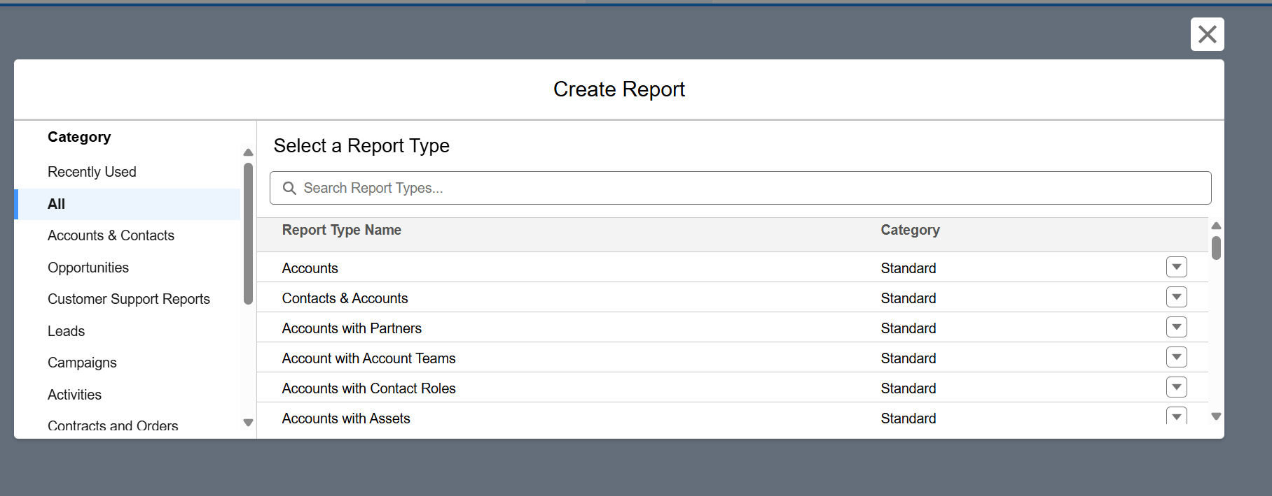

🤝 2. Share a Report Folder

📍 Steps:
- Go to the folder you just created.
- Click the dropdown arrow (▾) next to the folder name.
- Choose “Share”.
- In the sharing window:
  - Select Users, Roles, Public Groups, or Roles and Subordinates
  - Set access level:
    - Viewer
    - Editor
    - Manager
- Click Done, then Close.
🔐 Your folder is now accessible by selected users with the permissions you chose.
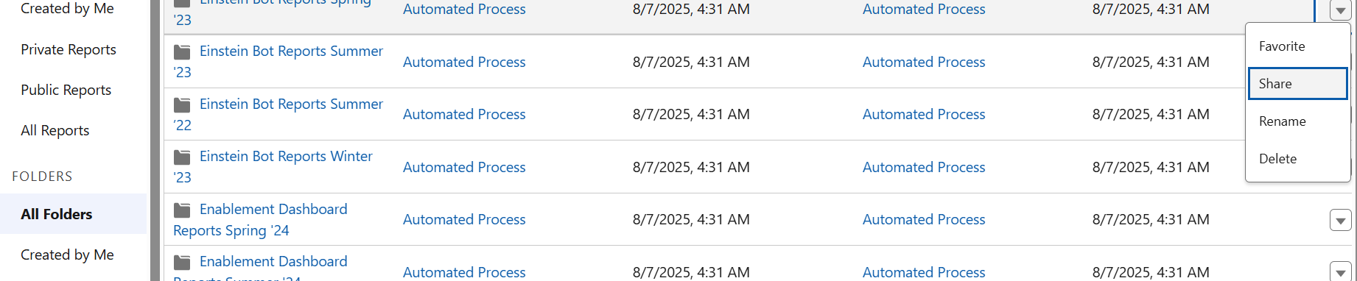

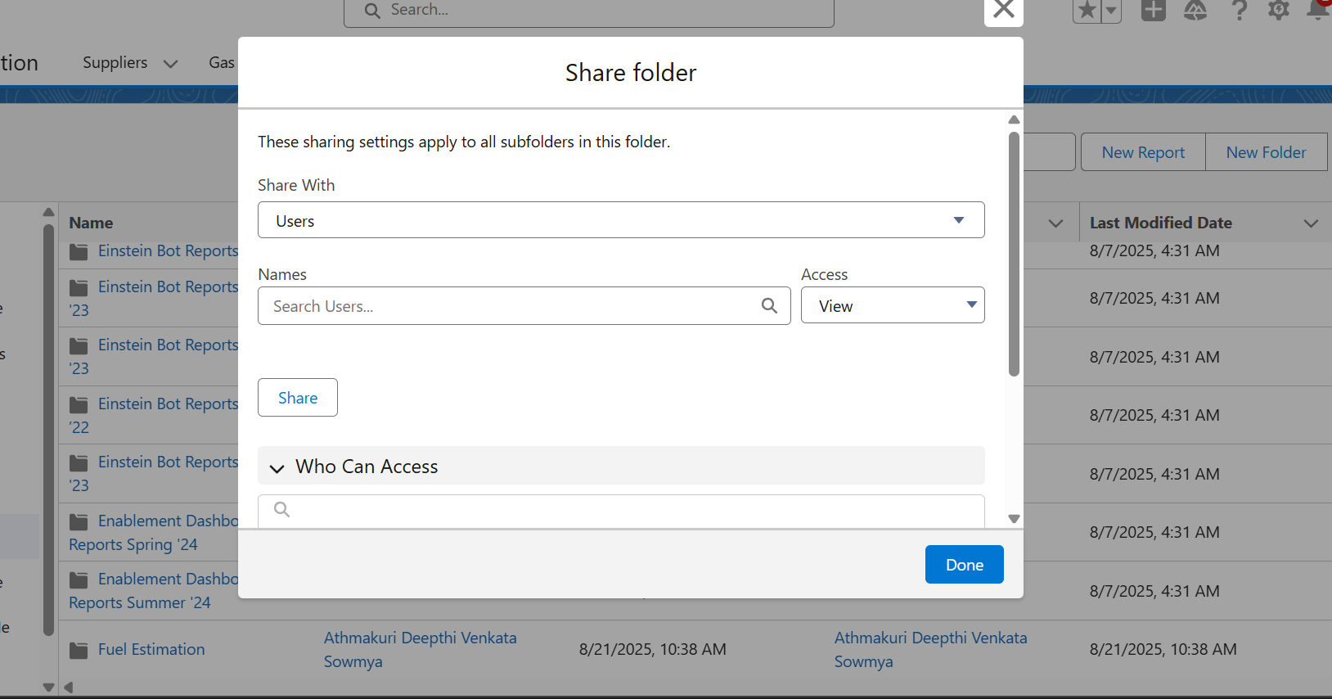

📊 3. Create a Report and Save it in the Folder

📍 Steps:
- Click “New Report” from the Reports tab.
- Choose a report type (e.g., Opportunities, Accounts with Contacts).
- Click Continue.
- In the Report Builder:
  - Add fields, filters, grouping as needed.
  - Add a chart if desired (click “Add Chart”).
- Click Save & Run.
- In the Save dialog:
  - Name your report (e.g., Closed Deals Q3)
  - Choose the folder you created earlier
  - Click Save
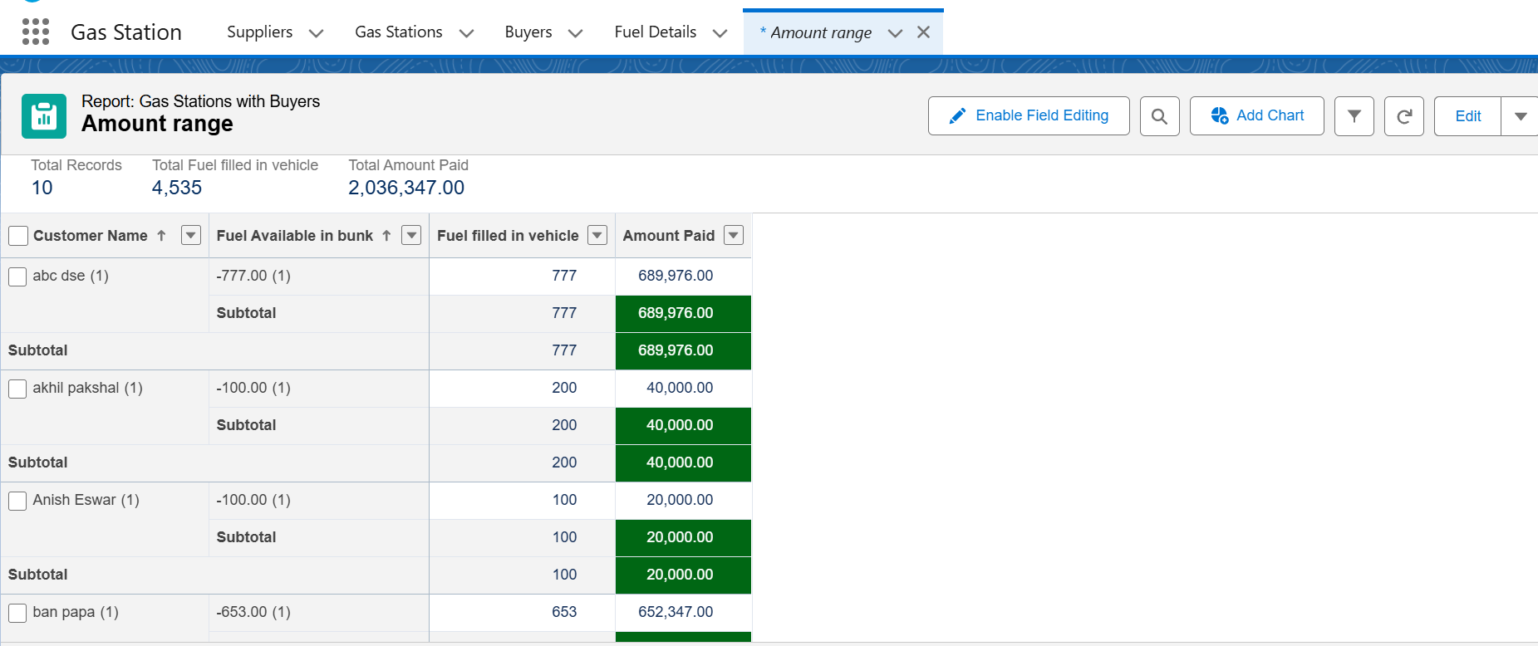
- Dashboards
A Dashboard in Salesforce is a visual representation of reports, where each component displays data from a report using visuals like:
- Bar charts 📊
- Pie charts 🥧
- Gauges 🕹️
- Metrics 🔢
- Tables 📋

✅ Steps to Create a Dashboard in Salesforce (Lightning)

🔹 1. Open the Dashboards Tab
- Click the App Launcher (🔍 9 dots) → Type and select “Dashboards”
- Click “New Dashboard”

🔹 2. Create the Dashboard
Fill in the dashboard info:
Field | Description
Name | Example: Sales Team KPIs
Folder | Choose a folder (use same one as related reports)
Description(optional) | For clarity click continue

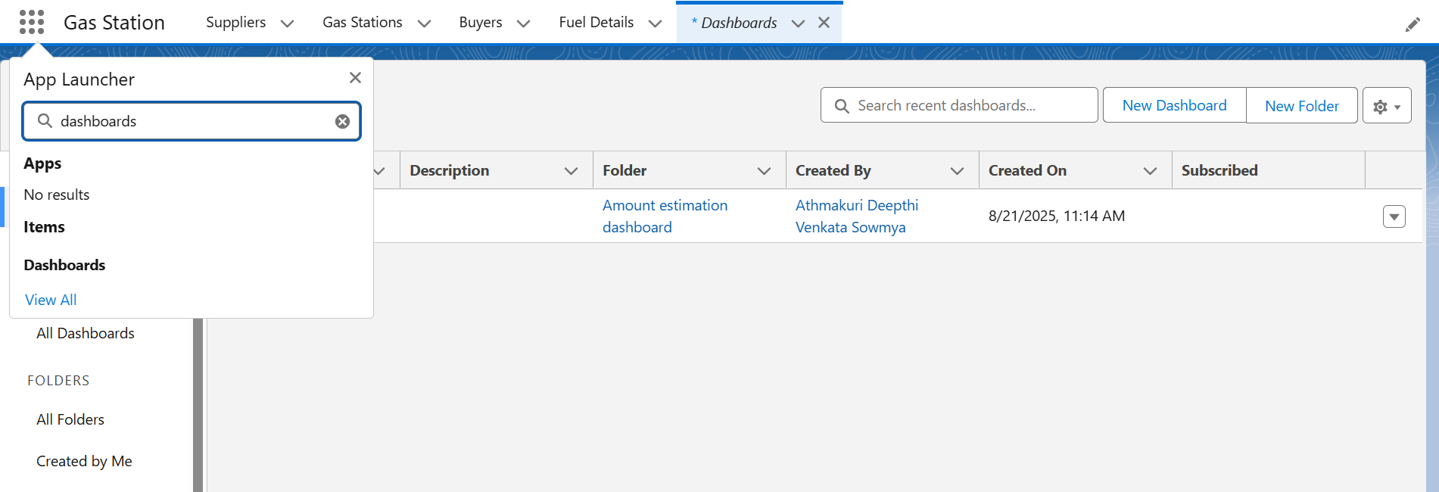

🔹 3. Add Components (Charts/Graphs)
After the dashboard canvas opens:
- Click + Component
- Select a source report (must be a Summary or Matrix report)
- Choose a component type:
  - Bar, line, pie chart
  - Metric or gauge
  - Table
- Customize:
  - Title
  - X/Y Axis (for graphs)
  - Groupings
  - Display units
- Click Add
Repeat to add more components!

🔹 4. Arrange & Resize
- Drag components to rearrange layout.
- Click and drag the corners to resize.
- Use sections for grouping related visuals.

🔹 5. Save and View
- Click Save to keep changes
- Click Done to exit the builder
- Click Refresh to pull latest data from reports

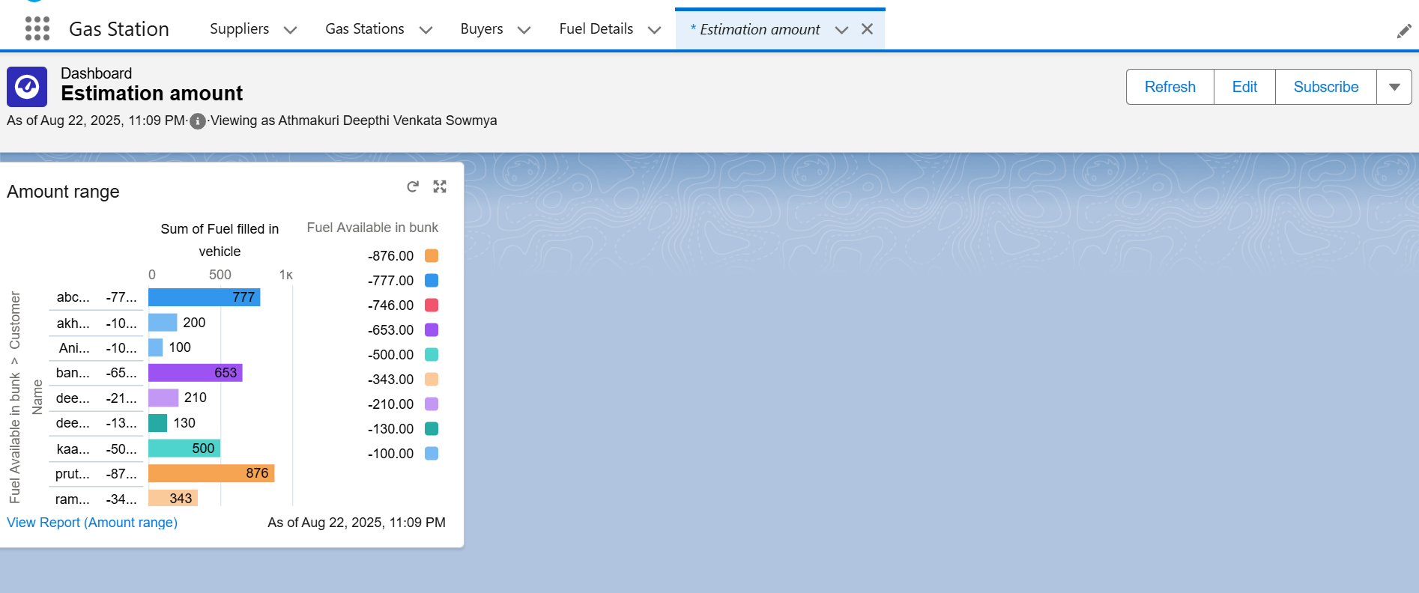
- Flows
Flows in Salesforce are part of Flow Builder, a powerful automation tool that allows you to automate complex business processes without writing code.
Flow Type | Use Case
Record-Triggered Flow | Auto-run when a record is created, updated, or deleted
Scheduled Flow | Run automatically on a schedule (e.g., nightly)
Screen Flow | Displays forms/screens for user interaction
Auto-Launched Flow | Can be called from Apex, another flow, or a button

✅ Steps to Create a Flow in Salesforce

Step 1: Open Flow Builder
- Go to Setup
- In Quick Find, type “Flows”
- Click “Flows”
- Click “New Flow”
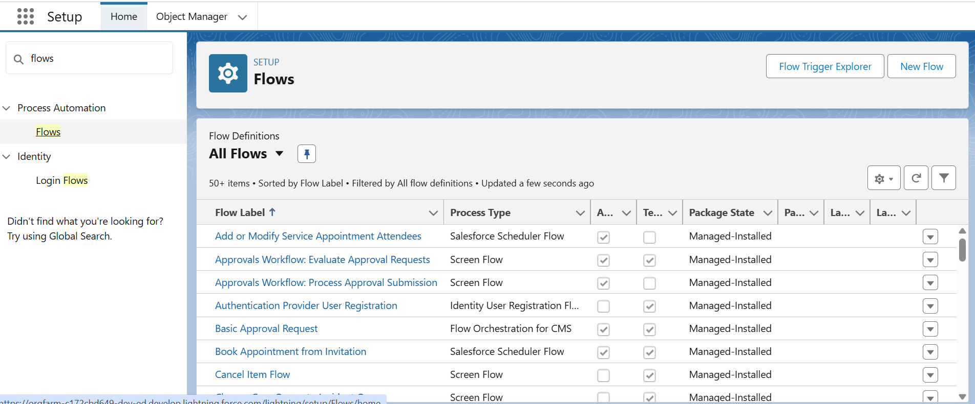

Step 2: Choose Flow Type
Pick a flow type depending on what you need:
- Record-Triggered Flow – for automation based on record changes
- Screen Flow – for guided user inputs
- Auto-Launched Flow – background processes
Click Create.
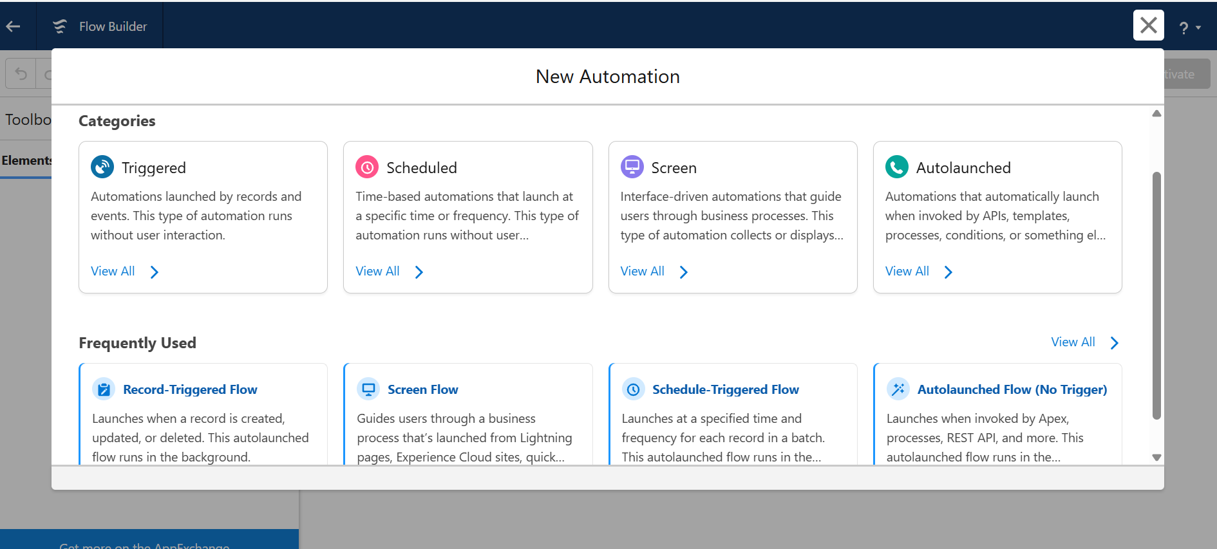

Step 3: Build Your Flow (Drag & Drop)
You’ll see a canvas where you can build the logic using Elements:
Element | Description
Get Records | Query records from the database
Create Records | Add new records
Update Records | Modify existing ones
Delete Records | Remove records

Step 4: Configure Start Element
For Record-Triggered Flows:
- Choose:
  - Object (e.g., Account)
  - Trigger (Create, Update, Delete)
  - Entry Conditions
  - Run Options (Before/After Save)

Step 5: Connect the Elements
- Drag lines between elements to define flow logic.
- Use Decisions for branching logic.
- Add Assignments to set values dynamically.

Step 6: Save and Activate
- Click Save, give your flow a name.
- Then click Activate to start using it.
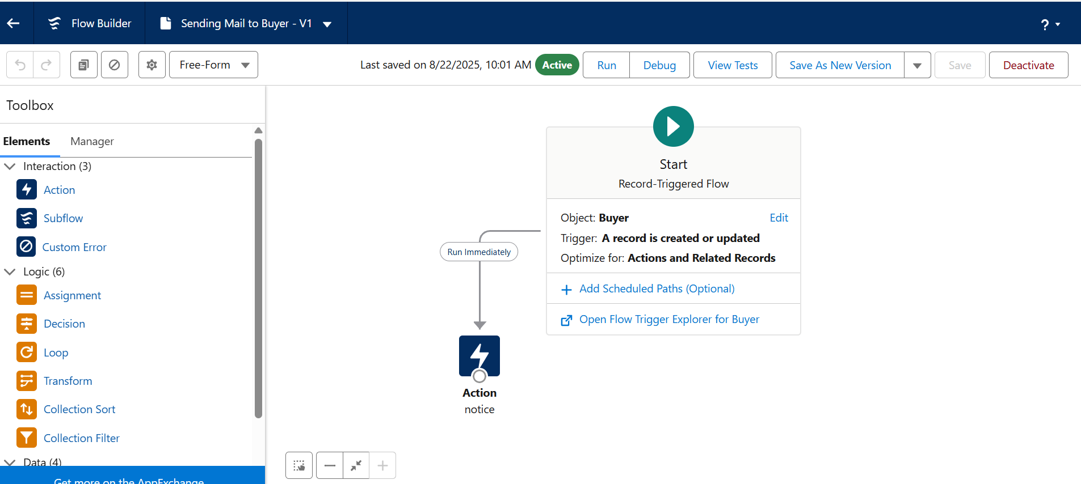
- Apex Trigger
An Apex Trigger is a piece of code that runs automatically in Salesforce when certain events happen on a record — like create, update, delete, or undelete.
🔁 Types of Trigger Events
Event | When It Runs
before insert | Before a new record is saved to DB
before update | Before an existing record is updated
before delete | Before a record is deleted
after insert | After a new record is inserted
after update | After a record is updated
after delete | After a record is deleted
after undelete | When a deleted record is restored

- Apex Handler
An Apex Handler is a separate Apex class that contains the business logic for a trigger. Instead of writing all your code inside the trigger, you delegate the logic to this class. This keeps your code modular, reusable, testable, and follows best practices.
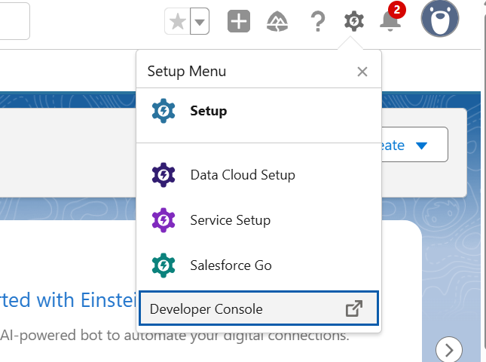

💻 How to Use Apex Trigger and Handler from Developer Console
- Apex Trigger

✅ 1. Open Developer Console
- Log into Salesforce
- Click the ⚙️ Gear Icon (top right) → Select Developer Console

✅ 2. Create the Apex Trigger
- In Developer Console:
  - Go to File → New → Apex Trigger
- Choose:
  - Trigger Name: AccountTrigger
  - Object: Account
- Paste this sample code:
trigger AccountTrigger on Account (before insert, before update) {
AccountTriggerHandler.handle(Trigger.new, Trigger.old, Trigger.operationType);
}
- Click File → Save

✅ 3. Create the Apex Handler Class
- Go to File → New → Apex Class
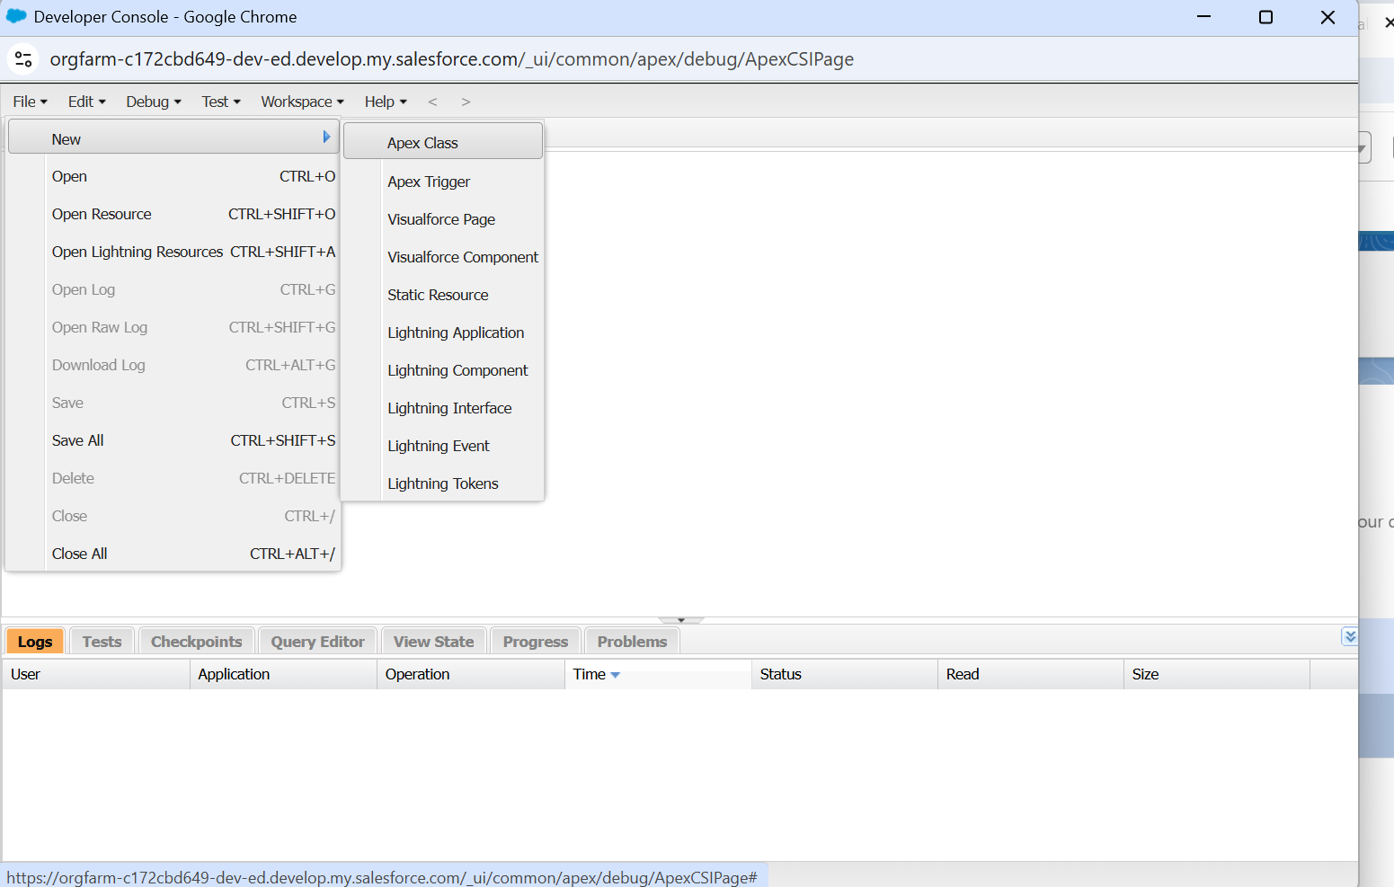
2. Name it: “FuelRecordHandler ”.
3. Paste this code:
public class FuelRecordHandler {
public static void beforeDeleteInfo(list<Fuel_details__c> fuelList){
//fuelList = [select Id from Fuel_details__c];
for(Fuel_details__c ful : fuelList){
if(ful.Fuel_supplied__c > 500){
ful.addError('you cannot delete the fuel details record because it is associated with supplier and Gas station records');
}
}
}
public static void beforeDeleteGas(list<Gas_Station__c> gasList){
//fuelList = [select Id from Fuel_details__c];
for(Gas_Station__c gas : gasList){
if(gas.Fuel_price_liter__c <= 50){
gas.addError('enter the fuel price before saving the record, Minimum price should be 50');
}
}
}
}
4. Click File → Save
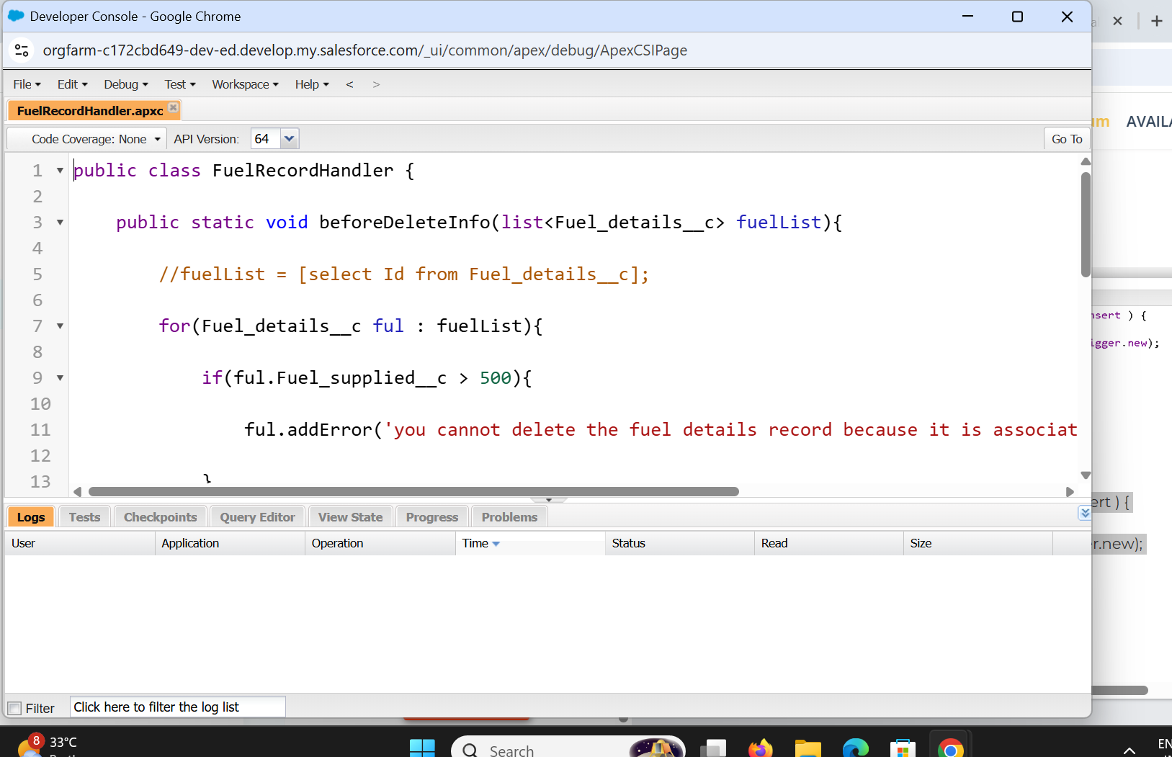
- Apex Handler

🧰 Step-by-Step in Developer Console

🔹 1. Open Developer Console
- In Salesforce, click ⚙️ Gear Icon → Developer Console

🔹 2. Create the Trigger
- Go to File → New → Apex Trigger
- Name: beforeDelete
- Choose Object: FuelDetails__c
- Paste this code:
code1:
trigger beforeDelete on Fuel_details__c (before Delete) {
if(trigger.isbefore && trigger.isDelete){
FuelRecordHandler.beforeDeleteInfo(trigger.old);
}
}
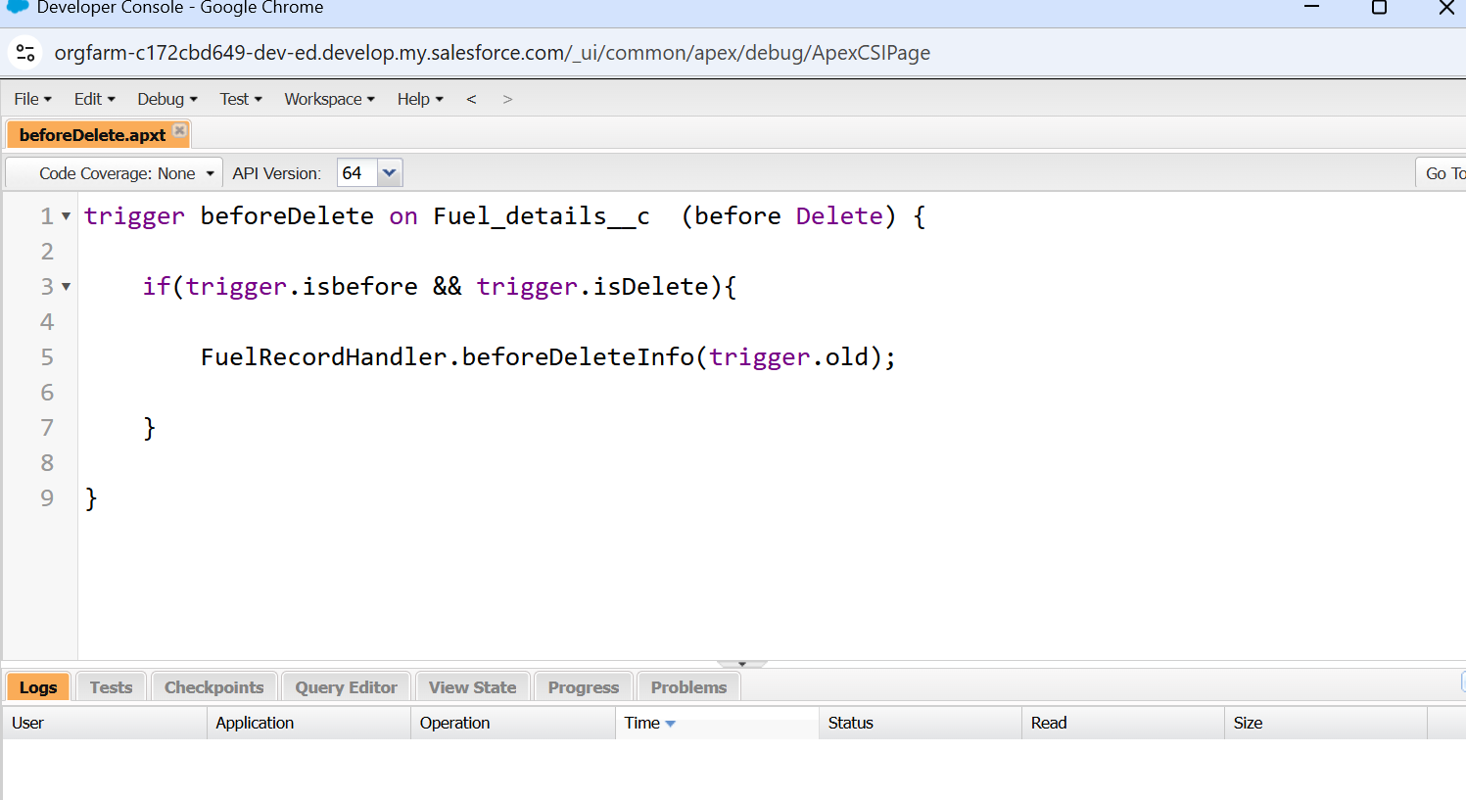
code2:
- Name: beforeInsert
- Choose Object: GasStation__c
- Paste this code:
trigger beforeInsert on Gas_Station__c (before insert ) {
if(trigger.isbefore && trigger.isinsert){
FuelRecordHandler.beforeDeleteGas(trigger.new);
}
}
